BUSINESS INTELLIGENCE: HAPPYPHONES LTD

# TASK 1

**QUERY 1**

**SELECT**

q**.**QuestionTopic**,**

dt**.**DateYear**,**

dt**.**DateMonth**,**

**AVG(**qh**.**QueryResolutionBalance**)** **AS** avg_resolution_time

**FROM**

QueryHandleFact qh

**JOIN**

QuestionDim q **ON** qh**.**QuestionID **=** q**.**QuestionID

**JOIN**

DateTimeDim dt **ON** qh**.**DateTimeID **=** dt**.**DateTimeID

**GROUP** **BY**

q**.**QuestionTopic**,** dt**.**DateYear**,** dt**.**DateMonth

**ORDER** **BY**

dt**.**DateYear**,** dt**.**DateMonth**,** q**.**QuestionTopic**;**

Screenshot of query running:

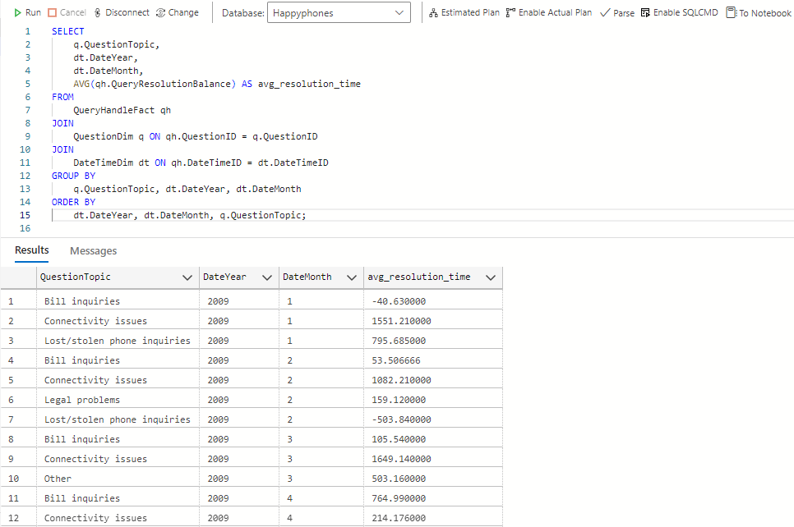

Business rationale:

Comprehending the mean duration required to answer various question topics on a monthly basis facilitates the identification of inefficient areas and supports more effective resource distribution.

**QUERY 2**

**SELECT**

dep**.**DepartmentName**,**

rep**.**RepresentativeFirstName**,**

rep**.**RepresentativeLastName**,**

**COUNT(**f**.**QueryResolutionBalance**)** **AS** escalated_queries

**FROM**

QueryHandleFact f

**JOIN**

DepartmentDim dep **ON** f**.**DepartmentID **=** dep**.**DepartmentID

**JOIN**

RepresentativeDim rep **ON** f**.**RepresentativeID **=** rep**.**RepresentativeID

**WHERE**

f**.**LevelOfEscalation **=** 'Yes'

**GROUP** **BY**

dep**.**DepartmentName**,** rep**.**RepresentativeFirstName**,** rep**.**RepresentativeLastName

**ORDER** **BY**

escalated_queries **DESC;**

Screenshot of query running:

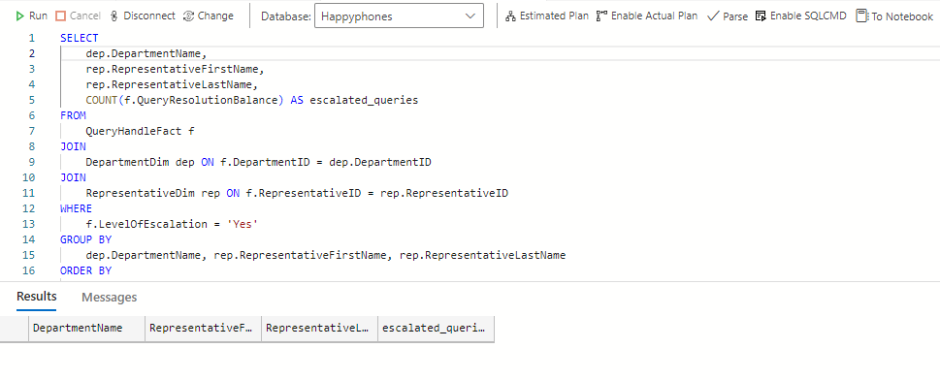

Business rationale:

In order to improve overall customer satisfaction, departments and representatives with a high number of escalated queries can be identified. This helps identify areas that may require more training or support.

**QUERY 3**

**SELECT**

q**.**QuestionSeverity**,**

dt**.**DateAmPm**,**

**AVG(**TRY_CAST**(**qh**.**CustomerSatisfactionLevel **AS** FLOAT**))** **AS** avg_satisfaction

**FROM**

QueryHandleFact qh

**JOIN**

QuestionDim q **ON** qh**.**QuestionID **=** q**.**QuestionID

**JOIN**

DateTimeDim dt **ON** qh**.**DateTimeID **=** dt**.**DateTimeID

**WHERE**

TRY_CAST**(**qh**.**CustomerSatisfactionLevel **AS** FLOAT**)** **IS** **NOT** **NULL**

**GROUP** **BY**

q**.**QuestionSeverity**,** dt**.**DateAmPm

**ORDER** **BY**

q**.**QuestionSeverity**,** dt**.**DateAmPm**;**

Screenshot of query running:

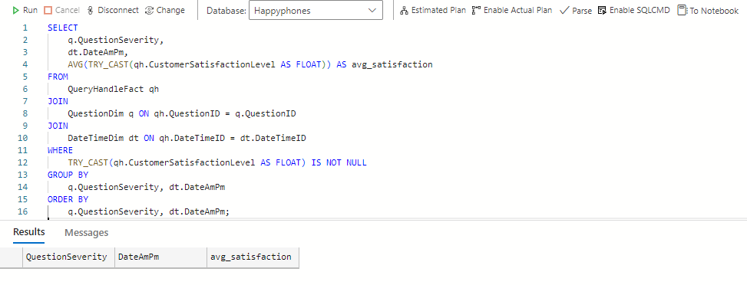

Business rationale:

In order to enhance service quality, it is helpful to schedule more experienced people during peak times, which can be determined by analysing customer satisfaction rates depending on query topic and time of day.

# TASK 2

We can include a new dimension table called KnowledgeBaseDim to enhance the schema and address the knowledge base's underutilization. This dimension will monitor the articles or other resources that customer support agents utilize to address consumer inquiries.

**New Dimension Table: KnowledgeBaseDim**

|  |  |  |
| --- | --- | --- |
| **Column Name** | **Data Type** | **Description** |
| KnowledgeBaseID | INT | Unique identifier for the knowledge base entry |
| ArticleTitle | VARCHAR | Title of the knowledge base article |
| ArticleContent | TEXT | Content of the knowledge base article |
| ArticleCategory | VARCHAR | Category or type of the article |
| DateCreated | DATE | Date when the article was created |
| LastUpdated | DATE | Date when the article was last updated |
| UsageFrequency | INT | Number of times the article has been used |

**Rationale:**

Insights into the frequency and efficiency with which customer support representatives utilize the knowledge base will be obtained by adding the KnowledgeBaseDim. Using this knowledge, one can:

1. Boost Knowledge Base Utilization: We may find gaps in the knowledge base and enhance the material to better support representatives and consumers by monitoring whether articles are commonly used or underutilized.
2. Training and Development: By identifying the most utilized articles, it is possible to identify recurring problems and areas in which representatives could require more assistance or training.
3. Efficiency in client Service: We can evaluate how well the knowledge base performs in promptly and precisely resolving client issues by tying its utilization to metrics related to query resolution.

**Integrating with Existing Schema:**

The KnowledgeBaseDim can be integrated with the QueryHandleFact table through a new column KnowledgeBaseID, which tracks the specific article used to resolve each query.

Modified QueryHandleFact Table:

|  |  |  |
| --- | --- | --- |
| **Column Name** | **Data Type** | **Description** |
| CustomerID | INT | Foreign key to CustomerDim |
| DateTimeID | INT | Foreign key to DateTimeDim |
| QuestionID | INT | Foreign key to QuestionDim |
| RepresentativeID | INT | Foreign key to RepresentativeDim |
| DepartmentID | INT | Foreign key to DepartmentDim |
| MobilePlanID | INT | Foreign key to MobilePlanDim |
| KnowledgeBaseID | INT | Foreign key to KnowledgeBaseDim |
| LengthOfCall | INT | Duration of the call in minutes |
| LevelOfEscalation | INT | Escalation level (1 - first line, 2 - second line) |
| CustomerSatisfactionLevel | INT | Customer's satisfaction level |
| QueryResolutionBalance | DECIMAL | Balance or cost associated with query resolution |

# TASK 3

https://public.flourish.studio/story/2493326/

Account credentials

Email: poojith250195@gmail.com

Password: Log in with Google

# TASK 4

Q1:

1. Organizations will not have the expertise in the new concepts and techniques to effectively use the new tools

Q2:

1. Data quality problems are often caused by conflicting data silos

Q3:

1. Consistent templates

Q4:

1. Once created, the data marts will keep on being updated from the data warehouse at periodic times

Q5:

a. Work out the visual details of multimedia items

1. Determine how the business person will interact with the application
2. Create the workflow between different analyses

Q6:

1. Enhancing user understanding